Exercise Adding Validations to Forms in PoolCarz Application

**ProblemStatement:**

* Add validations to **LoginComponent** as shown below:

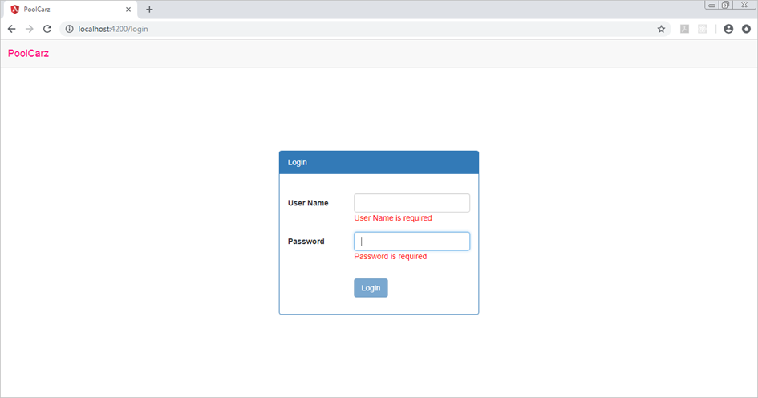

* Add required validation to username and password textboxes in LoginComponent and display appropriate error messages when validation fails as shown
* Also, check for the data validity using data stored in users array and render appropriate failure message as shown below:

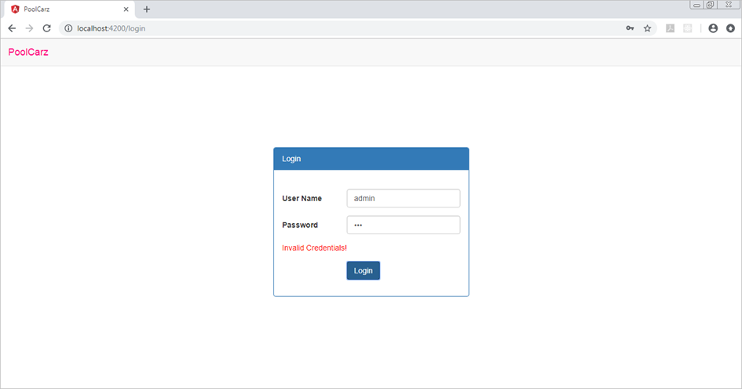

**Problem Statement:**

* Create **OfferRideComponent** as a reactive form with validations as shown below:

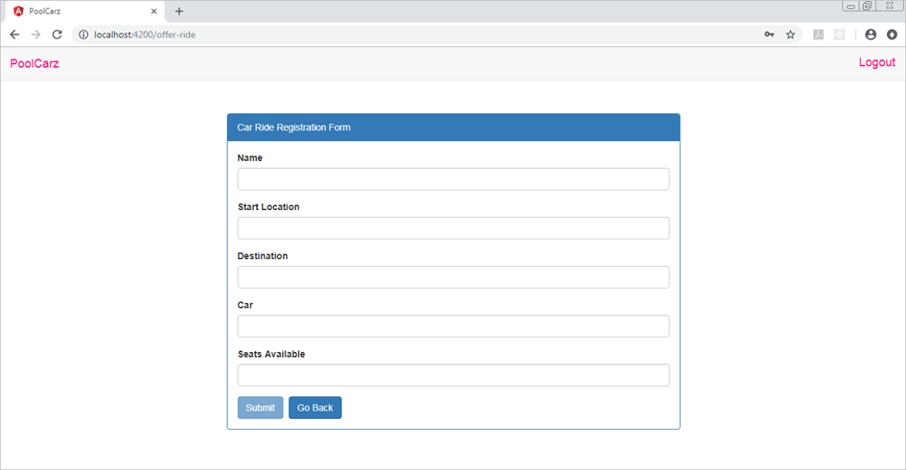

* Create **OfferRideComponent** using Angular CLI
* Create a reactive form as shown above. Add required validation to all the fields
* Create a custom validator to check if "Seats Available" textbox has value between 0 to 8. If validation fails, it should render error message as shown below:

